In this experiment, we examined how different parts of typing affected how we feel about words. Participants were given a typing test and asked to indicate their dominant writing hand. They were then given words to rate for how pleasant they where (1 very unpleasant to 9 very pleasant).

|  |  |  |
| --- | --- | --- |
| Hand | Word Speed | Ratings |
| Left | 49 | 5.6 |
| Left | 37 | 4.4 |
| Left | 36 | 5.6 |
| Right | 58 | 3.2 |
| Right | 32 | 6.8 |
| Left | 38 | 3.2 |
| Left | 46 | 4.8 |
| Right | 62 | 4.6 |
| Right | 47 | 5.0 |
| Right | 28 | 4.8 |

If we wanted to determine if handedness affected word ratings (i.e. is there a difference between left and right handers ratings for pleasantness of words), what is:

1. The independent variable: **Handedness**
   1. The levels of variable: **Left and Right**
   2. The type of variable using the NOIR system: **Nominal**
2. The dependent variable: **Word ratings**
   1. The type of variable using the NOIR system: **Interval**
   2. Create a histogram of the dependent variable.

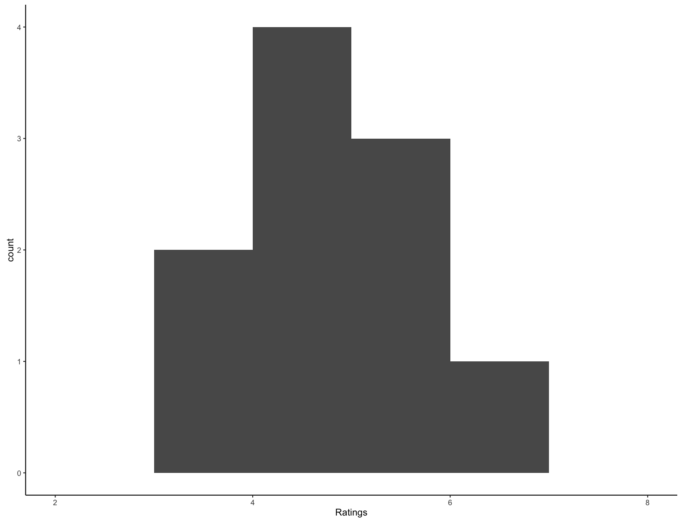

* + 1. What is the shape of the histogram? **Unimodal (normal)**

1. What are some potential confounds to our study? **The words we picked, the time of day, natural feelings about words**
2. Create a graph that displays the results of the differences between left and right-handers on word ratings.

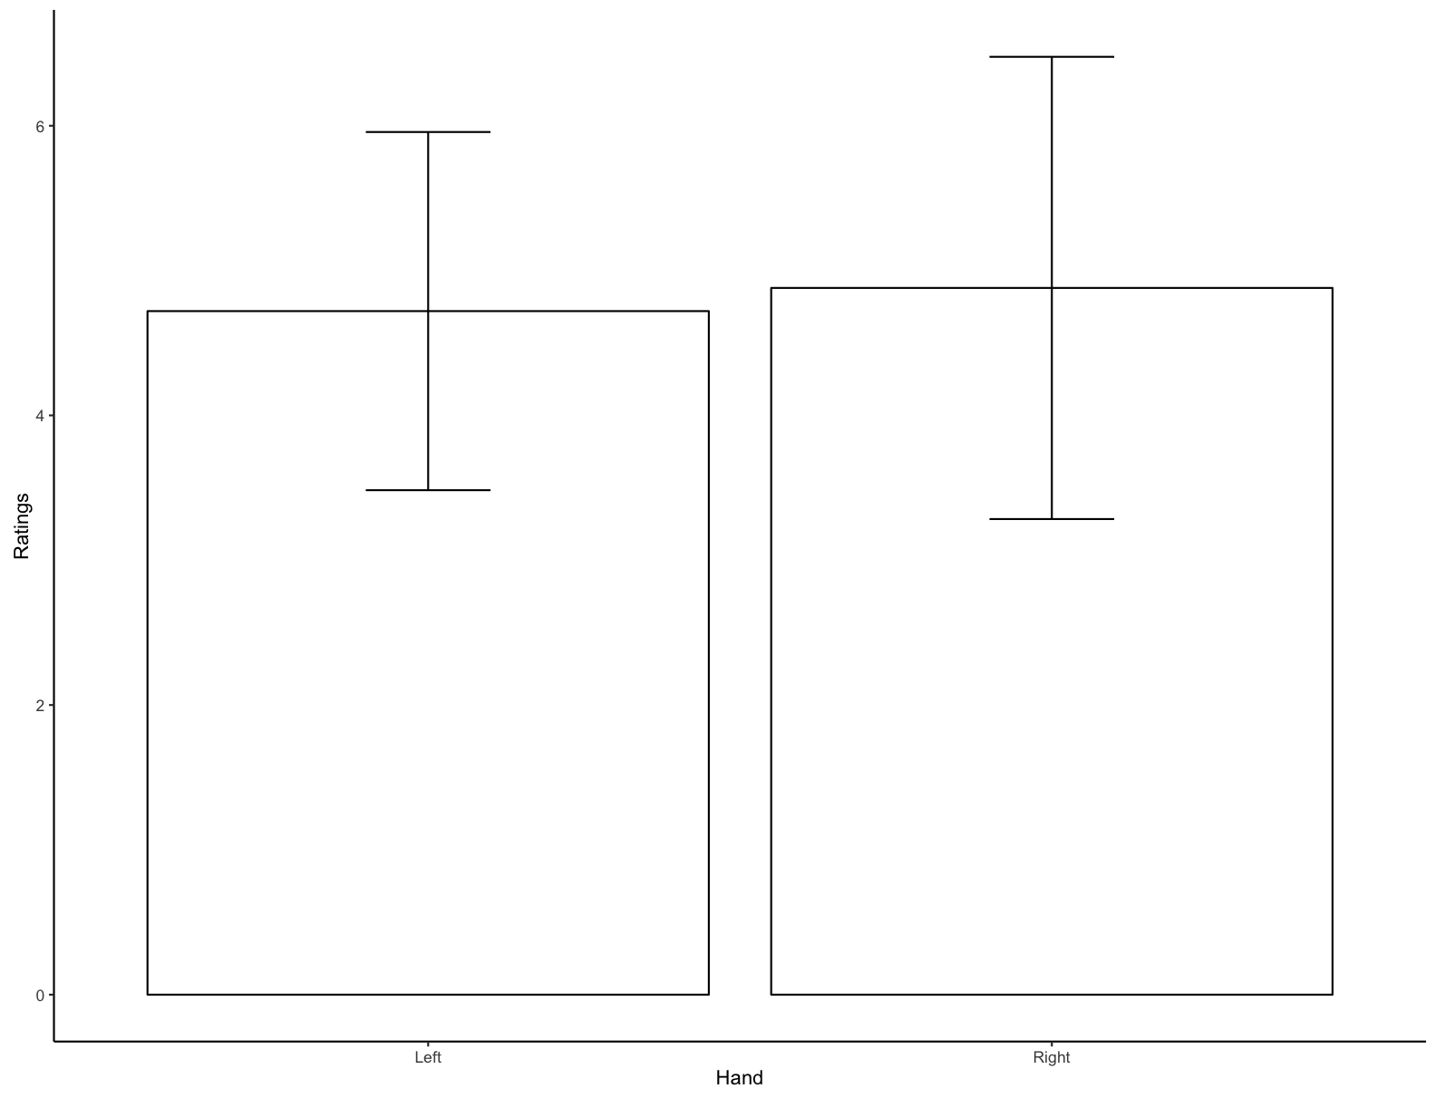

* 1. Which group has the higher ratings for words? **Right just barely (equalish)**

1. We were also interested in how typing speed affected word ratings. Create a graph that shows that relationship.

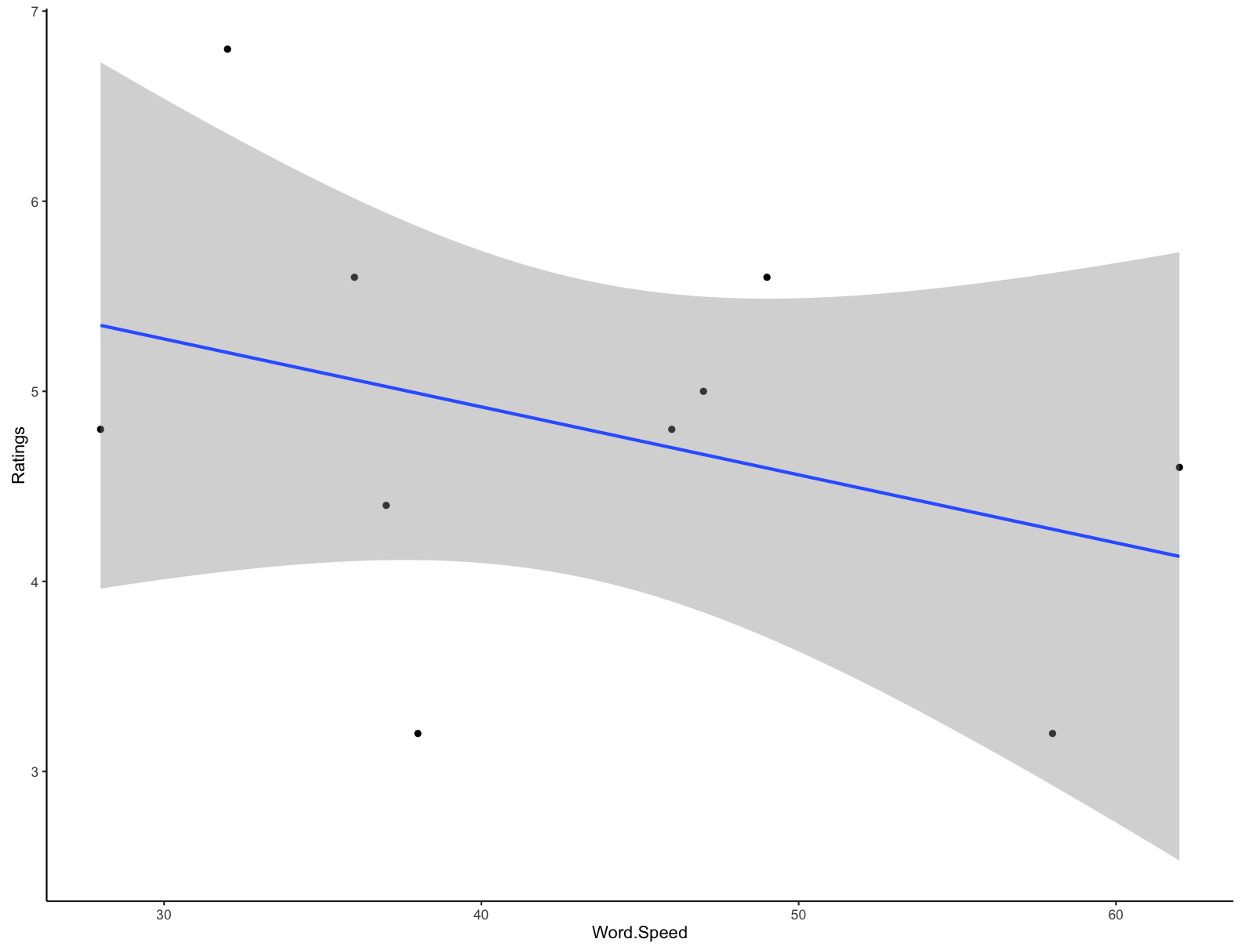

1. For the ratings variable, calculate the following:
   1. Mean: 4.8
   2. Median: 4.8
   3. Mode: [1] "3.2" "4.8" "5.6"
   4. Interquartile range: 1
   5. *Biased* standard deviation 1.03
   6. *Biased* variance 1.06

> summary(examdata$Ratings)

Min. 1st Qu. Median Mean 3rd Qu. Max.

3.20 4.45 4.80 4.80 5.45 6.80

> pop.var(examdata$Ratings)

[1] 1.064

> pop.sd(examdata$Ratings)

[1] 1.031504